**LAB Book partners up with Practical Tableau Book: Used for Tableau Desktop Level 2**

**This Lab book is Part 3 of 5 Parts. [APPROX TIME – 70 MIN]**

Part 3 – Tips and Tricks

Chapter 47 - Exercise (Icons) - 10 Minutes – Book Pages: 295-299

1. Before you begin:
   1. Go out to Windows Explorer and go to: \documents\My Tableau Repository\Shapes
   2. Leave this open
   3. Go to the Desktop Level 2 Folder (where our class files are)
   4. Open the Images folder
   5. Right click the “Sports” folder and press CTRL + C to copy
   6. Go back to the open Windows Explorer and press CTRL + V to paste the folder into your Shapes directory
2. Create a new workbook using the Sample – Superstore Saved Data Source from the connection pane on Tableau’s Start Page.
3. Save and name the Workbook PartThree.twbx. (There is a copy of this workbook in the WORKBOOKS folder that has the solutions for the labs.)
4. Rename Sheet1 and call it Icons. Color the sheet tab if desired.
5. Get a new data source - Icons.xlsx – located in your Data Sources folder (part of downloaded data).
6. Select that data source in the Data tab to set the available fields for building the view.
7. There is only one dimension named Icon Name – drag it to the Rows shelf.
8. Change the Mark type from Automatic to Shape on the Marks Card.
9. Drag Icon Name dimension to the Shape shelf in the Marks card.
10. Notice that Tableau encoded a shape to each of your Icon Names. Also notice you got a new legend to describe each shape.
11. Click the Shape shelf.
12. Under the Select Shape Palette option click the arrow pointing down next to “Default” Look for your Sports Folder (if you do not see it, Click the “Reload Shapes” button at the bottom.
13. Assign each Sports Icon Name to a picture by clicking the name, then clicking the corresponding picture (EX: Women’s Basketball to the icon that IS Women’s Basketball).
    1. Note: choosing to Assign Palette command will speed up this step.
14. When they are all associated, Click OK – see each new custom Icon on your Worksheet.
15. Next, click the New Dashboard tab at the bottom of your Workbook to create a new dashboard.
16. Name it Icon Dashboard and color it the same color as your Icon Worksheet (if you colored it)
17. Drag the Icons worksheet into the dashboard canvas.
18. Go to the Dashboard menu item above and choose Actions… from the drop-down list.
19. When in the **Actions** dialog box, click “Add Action” at the bottom
20. Choose Filter from the list
21. Name this Click Icons

Under both **SOURCE** and **TARGET**, make sure that your Icons sheet is selected and be sure that your Run Action On option (right side of screen) is set to Select. If it is not, click “Select”

1. **Also Notice the option that says "Clearing the Selection Will” and notice the option is set to Show All Values
2. Click OK – notice your new Filter Action in the Dialogue Box
3. Click Ok again.
4. Set the Fit viewing option (on toolbar) to Entire View.
5. Click an Icon. Notice it will select that Icon and show it to you in a “Zoom” mode
6. To get back to all Icons, click in a white area around the image. This is because your option was set to “Show All Values” when choosing “Clearing the Selection” (from step 23).

Chapter 48 - Exercise (What-If) - 10 Minutes – Book Pages: 301-305

1. Create a new worksheet and name it What If. Color the sheet tab if desired.
2. Select the Sample Superstore data source.
3. Create a Parameter:
   1. Name: What If
   2. Data Type: Integer
   3. Allowable Values: Range
   4. Click all three boxes(Minimum, Maximum, Step)
      1. Minimum: **0**
      2. Maximum: **100**
      3. Step: **5**
4. Click OK
5. Create a new calculated field:
   1. Name: What-If Sales

ALT - you can drag and drop your Sales Measure and your What-If Parameter into the calculation as you type, or you can copy below: (or use Solution)

* 1. The calculation is: [Sales] * (1 + [What-If] /100)
  2. Click OK

1. Right-drag the Order Date dimension to the Columns shelf. In the Drop Field pop-up, choose the green (continuous) MONTH Order Date (4th option from bottom)
2. Drag your Measure Values measure into the Rows shelf – notice one of “each” Measure appears. In the end, you will only want the Sales measure and the What-if Sales measure here.
   * One method to accomplish this is to select Discount (The first measure in the **Marks Card**!), Then hold your Shift key down (and keep holding it down) and select the Quantity pill (so that it selects them both and everything in between) in the Marks Card. While you still have your SHIFT key held down, right-click into one of those selected fields and choose Remove. All but Sales and What-If Sales should be removed.
   * Another method, drag Measure Names from dimensions into Filters shelf, choose None, then select only Sales and What-If Sales to only show those measures in the filter.
3. Notice that your Measure Names dimension will move to the FILTER shelf and if you edit it (just to look at it), you will notice it has been filtered for Sales and What-If Sales.
4. Move the Measure Names dimension to the Color shelf on the Marks Card – you will now have two colored lines in your view (though overlapping/atop each other). If desired, click on the Color Shelf and re-associate Sales and What-if Sales to your desired color(s) and click OK
5. Right-click the What If parameter and Show Parameter Control. This control provides a slider to change the Sales and the What-if Sales to show the “forecast” of sales if the What-If (% increase) changes.
6. Edit the Title… for the color legend to list: “Showing Sales & % Increases”
7. Edit the Label card to Show Mark Labels | Highlighted
8. Edit the worksheet Title to show:

**The *What-If Sales* Multiplier shows a forecasted <Parameters.What If>% increase in sales.**

Chapter 49 - Exercise (Alert 1) - 15 Minutes – Book Pages: 307-311. Note: Chapter 66 is also referenced to create the Parameter & calculated field.

1. Get a new sheet and call it Alerts 1. Color the sheet tab if desired.
2. Choose to use Sample – Superstore data source for the worksheet.
3. Create a Parameter as follows:
   1. Name: Set Date Aggregation
   2. Type: String
   3. Choose List from Available Values
   4. Type in your custom list by clicking first into the value field, then double clicking the Display field. Set them up as follows: (be sure to use all small letters on the Value (left) side.

|  |  |
| --- | --- |
| day | Day |
| week | Week |
| quarter | Quarter |
| month | Month |
| year | Year |

1. Show the parameter control. Change format/layout of the parameter to Single Value List.
   1. Create a calculation and name it Date Choice.

DATETRUNC([Set Date Aggregation], [Order Date])

1. Place the Sales measure on the Rows shelf.
2. Right-drag Date Choice dimension onto the Column shelf and choose the first option [**Date Choice (Continuous**)].
3. Right-click drag Order Date dimension to Label card in Marks Card and choose MIN (Order Date).
4. Repeat step 7 (above) and choose MAX (Order Date).
5. Next, change the Title of the worksheet to read:

**This worksheet shows data aggregation by date range set to: <Parameters.Set Date Aggregation>.**

* + 1. Hint: if you accidentally delete any of the fields, you can use the INSERT tool to get them back (take a look by clicking, to see what is available)
    2. Format the text as desired and then click OK (once).

1. Test the Set Date Aggregation parameter control by changing the date parts to reflect different granularities.

Chapter 49 - Exercise (Alert 2) - 5 Minutes – Book Pages: 309

1. Create a new worksheet and name it Alerts 2. Color the sheet tab if desired.
2. Right-drag Order Date dimension to Columns shelf and change to green MONTH (Order Date) Continuous.
3. Drag Sales measure to Rows shelf.
4. Create a calculation:
   1. Name: Dynamic Label Alert
   2. Calc:

IF SUM([Sales]) >= 97000 THEN "Extra Great"

ELSEIF SUM([Sales]) <= 12000 THEN “Extra Terrible"

ELSE NULL

END

1. Drag your new Dynamic Label Alert measure to the Label card. Format the Label card as desired.
2. Copy Dynamic Label Alert to Color Shelf.
3. Labels will automatically appear.

Chapter 49 - Exercise (Alert 3) - 10 Minutes – Book Pages: 310-311 *(Note: this is different example than book’s example)*

1. Get a new sheet and call it Alerts 3. Color the sheet tab if desired.
2. Drag Category and Ship Mode dimensions to Columns shelf.
3. Drag Region dimension to the Rows shelf.
4. Change the Marks type to Shape.
5. Create a calculation to show profit as a % of sales named KPI Ratio:

SUM([Profit]) / SUM([Sales])

1. Create a second calculation named KPI Ratio Color and Shape:

IF [KPI Ratio] >.12 THEN "Greater than 12%"

ELSEIF [KPI Ratio] <.05 THEN "Less than 5%"

ELSE "Between 5% and 12%"

END

1. Drag the KPI Ratio Color and Shape measure to the Color shelf.
2. Perform another drag and place the KPI Color and Shape measure on the Shapes Shelf.
   1. Choose Thin Arrows from the shape palette choices.
      1. Assign "Greater than 12%” with the UP arrow
      2. "Less than 5%" with DOWN arrow
      3. "Between 5% and 12”" with the RIGHT arrow.
3. Edit the Color Shelf. Pick Traffic Light –
   1. Associate "Greater than 12%" with a Green color
   2. "Less than 5%" with a Red color"
   3. "Between 5% and 12%" with a Yellow color.
4. Fit the view to Entire View just while we do the next part
5. Change the default number format for the KPI Ratio calculated field to "Percent" with NO decimal places - right click and go to default properties, number, then choose percent, and no decimal places.
6. Drag KPI Ratio to Label card. Adjust mark label alignment if desired (e.g., right,
7. horizontal alignment)
8. Use the pill for KPI Ratio Color and Shape, assigned to the Color Shelf, to sort the names to follow a logical traffic light order - you will need to use a Manual sort with the proposed order below:
   * 1. Green - "Greater than 12%”
     2. Yellow - "Less than 5%"
     3. Red - "Between 5% and 12”

Chapter 56 - Exercise (showing Concept of Dynamic Dashboard Views) - 10 Minutes – Rest of Book examples on Pages: 353-363

DYNAMIC VIEWS:

1. Use Sample – Superstore as data source.
2. Create a worksheet named: Dynamic View
3. Create a Parameter and name it **MeasureOptions**
4. Use the screenshot below to complete the parameter settings.

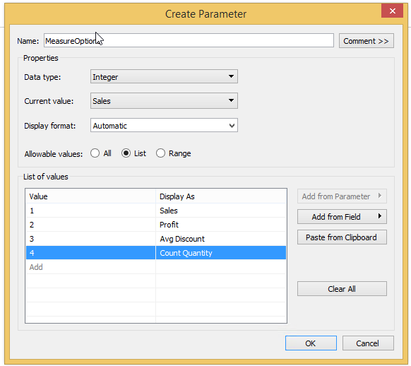

1. Create a calculated field: **ChoiceOfMeasure**

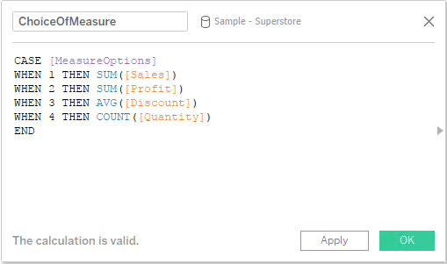

Assemble:

1. Right-drag Order Date dimension onto the Columns shelf and select Month (continuous).
2. Drag your new calculated field ChoiceOfMeasure to Rows shelf.
3. Drag Segment to Color
4. Right Click your Parameter (MeasureOptions) and choose Show Parameter Control
5. Additional formatting:
   1. Right-click the ChoiceOfMeasure axis, Edit the Axis. & delete the text in the Title
   2. Double Click Title of Worksheet and replace what is there with:

“**You are now looking at: <Parameters.MeasureOptions>.**“

* 1. Use the Analytics tab, add an Average Line, setting the scope to Table, and Label to Custom: (Computation | Value).

1. Change the parameter values.

Now, you get the option of more than one view!!!